**Circular Linked Lists: Operations in C Language**

In the last tutorial, we learned about this new data structure, the circular linked lists. Additionally, we discussed the difference and similarities between a circular linked list and a linear linked list.

Let me quickly summarize some of the most important points:

1. Unlike singly-linked lists, a circular linked list has no node pointing to NULL. Hence it has no end. The last element points at the head node.
2. All the operations can still be done by maintaining an extra pointer fixed at the head node.
3. A circular linked list has a head node, but no starting node.

We even learned traversing through the circular linked list using the do-while approach. Today, we’ll see one of the operations, insertion in a doubly-linked list with the help of C language.

Now, let's move on to the coding part. I have attached the snippet below. Refer to it while understanding the steps.

**Creating the circular linked list:**

1. Creating a circular linked list is no different from creating a singly linked list. One thing we do differently is that instead of having the last element to point to NULL, we’ll make it point to the head.
2. Refer to those previous tutorials while creating these nodes and connecting them. This is the third time we are doing it, and I believe you must have gained that confidence.
3. struct Node
4. {
5. int data;
6. struct Node *next;
7. };
8. int main(){
10. struct Node *head;
11. struct Node *second;
12. struct Node *third;
13. struct Node *fourth;
15. // Allocate memory for nodes in the linked list in Heap
16. head = (struct Node *)malloc(sizeof(struct Node));
17. second = (struct Node *)malloc(sizeof(struct Node));
18. third = (struct Node *)malloc(sizeof(struct Node));
19. fourth = (struct Node *)malloc(sizeof(struct Node));
21. // Link first and second nodes
22. head->data = 4;
23. head->next = second;
25. // Link second and third nodes
26. second->data = 3;
27. second->next = third;
29. // Link third and fourth nodes
30. third->data = 6;
31. third->next = fourth;
33. // Terminate the list at the third node
34. fourth->data = 1;
35. fourth->next = head;
37. return 0;
38. }

Copy

***Code Snippet 1: Creating the circular linked list***

**Traversing the circular linked list:**

1. Create a void function *linkedListTraversal*and pass the head pointer of the linked list to the function.
2. In the function, create a pointer *ptr* pointing to the head.
3. Run a *do-while* loop until *ptr*reaches the last node, and ptr-> next becomes head, i.e. ptr->next = head. And keep printing the data of each node.
4. So, this is how we traverse through a circular linked list. And *do-while* was the key to make it possible.
5. void linkedListTraversal(struct Node *head){
6. struct Node *ptr = head;
7. do{
8. printf("Element is %d\n", ptr->data);
9. ptr = ptr->next;
10. }while(ptr!=head);
11. }

Copy

***Code Snippet 2: Traversing the circular linked list***

**Inserting into a circular linked list:**

1. I’ll just cover the insertion part, and that too on the head. Rest of the variations, I believe, you’ll be able to do yourselves. Things are very similar to that of singly-linked lists.
2. Create a struct Node* function *insertAtFirst* which will return the pointer to the new head.
3. We’ll pass the current head pointer and the data to insert at the beginning, in the function.
4. Create a new struct Node* pointer *ptr*, and assign it a new memory location in the heap. This is our new node pointer. Make sure you don't forget to include the header file <stdlib.h>.
5. Create another struct node * pointer p pointing to the next of the head. *p = head-> next.*
6. Run a *while* loop until the p pointer reaches the end element and p-> next becomes the head.  
   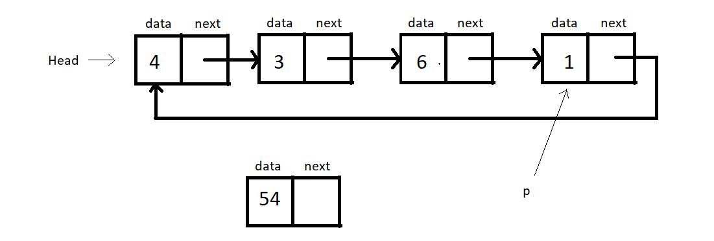
7. Now, assign *ptr*to the next of *p*, i.e.*p->next  = ptr*. And *head*to  the next of ptr, i.e. *ptr->next = head*.
8. Now, the new head becomes ptr. *head = ptr.*
9. Return head.
10. struct Node * insertAtFirst(struct Node *head, int data){
11. struct Node * ptr = (struct Node *) malloc(sizeof(struct Node));
12. ptr->data = data;
14. struct Node * p = head->next;
15. while(p->next != head){
16. p = p->next;
17. }
18. // At this point p points to the last node of this circular linked list
20. p->next = ptr;
21. ptr->next = head;
22. head = ptr;
23. return head;
25. }

Copy

***Code Snippet 3: Inserting into a circular linked list***

**Here is the whole source code:**

#include<stdio.h>

#include<stdlib.h>

struct Node

{

int data;

struct Node *next;

};

void linkedListTraversal(struct Node *head){

struct Node *ptr = head;

do{

printf("Element is %d\n", ptr->data);

ptr = ptr->next;

}while(ptr!=head);

}

struct Node * insertAtFirst(struct Node *head, int data){

struct Node * ptr = (struct Node *) malloc(sizeof(struct Node));

ptr->data = data;

struct Node * p = head->next;

while(p->next != head){

p = p->next;

}

// At this point p points to the last node of this circular linked list

p->next = ptr;

ptr->next = head;

head = ptr;

return head;

}

int main(){

struct Node *head;

struct Node *second;

struct Node *third;

struct Node *fourth;

// Allocate memory for nodes in the linked list in Heap

head = (struct Node *)malloc(sizeof(struct Node));

second = (struct Node *)malloc(sizeof(struct Node));

third = (struct Node *)malloc(sizeof(struct Node));

fourth = (struct Node *)malloc(sizeof(struct Node));

// Link first and second nodes

head->data = 4;

head->next = second;

// Link second and third nodes

second->data = 3;

second->next = third;

// Link third and fourth nodes

third->data = 6;

third->next = fourth;

// Terminate the list at the third node

fourth->data = 1;

fourth->next = head;

return 0;

}

Copy

***Code Snippet 4: Insertion and traversal in a circular linked list***

We’ll now see whether the functions work accurately. Let’s insert a few nodes at the beginning.

printf("Circular Linked list before insertion\n");

linkedListTraversal(head);

head = insertAtFirst(head, 54);

head = insertAtFirst(head, 58);

head = insertAtFirst(head, 59);

printf("Circular Linked list after insertion\n");

linkedListTraversal(head);

Copy

***Code snippet 5: Using the insertAtFirst function***

Refer to the output below:

Circular Linked list before insertion

Element is 4

Element is 3

Element is 6

Element is 1

Circular Linked list after insertion

Element is 59

Element is 58

Element is 54

Element is 4

Element is 3

Element is 6

Element is 1

Copy

As you can see, all the elements we passed into the *insertAtFirst*function got added at the beginning. So, it is indeed working.

And this was all about a circular linked list. We won’t go doing other operations. You should all carry out other operations yourselves. Believe me, it ain’t a tough job. We have next in the series another variant of a linked list called the doubly linked lists.

Thank you for being with me throughout. I hope you enjoyed the tutorial. If you appreciate my work, please let your friends know about this course too. If you haven’t checked out the whole playlist yet, move on to [codewithharry.com](https://codewithharry.com/) or my YouTube channel to access it. See you all in the next tutorial, and we’ll see another variant of linked lists, **Doubly Linked Lists**. Till then, keep learning.